# GL-Zigbee SDK User Guide

|  |  |  |  |
| --- | --- | --- | --- |
| Version | Changed Item | Author | Date |
| 1.0 | First version | Feng.He | 2020.06.16 |

## 1. Description

### 1.1 What’s GL-Zigbee SDK

GL-Zigbee SDK is developed and provided by GL-iNet Technology as a part of the zigbee solution. The SDK encapsulates the communication between the gateway and the zigbee module, allowing third-party developers to focus on the business layer rather than the communication layer.

There are two parts of GL-Zigbee SDK, zbdaemon and gl-zb-api. Zbdaemon is used to communicate with modules and process zigbee protocol stack. Gl-zb-api encapsulates the communication between the user application and the zbdaemon. To maintain the stability of zbdaemon, we separated it from the SDK, created and managed it in zbtool. So developers only need to call the apis, no need to maintain zbdaemon.

The overall structure is as follows:

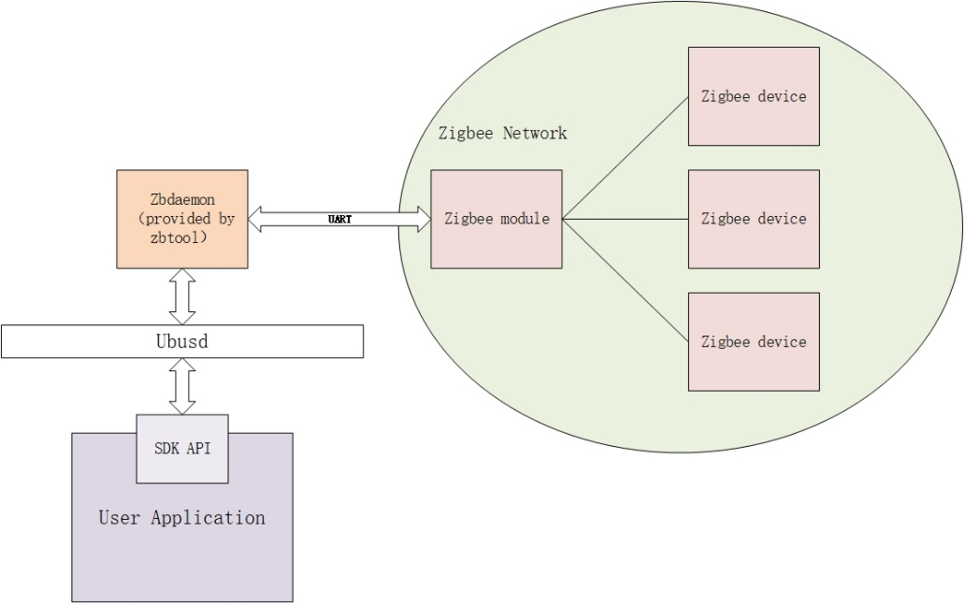

### 1.2 How to install zbtool

Because we haven't officially released the zbtool, you can only ssh to the router and install it using opkg.

opkg update

opkg install gl-zbtool_1.0.2_ipq806x.ipk

### 1.3 Directory structure of gl-zigbee_sdk

|—— Makefile

|

|—— src

|—— doc # document

| |—— version_log.md

|

|—— include # header file

| |—— libglzbapi.h

| |—— attribute-id.h

| |—— gl_z3_base.h

| |—— gl_zb_type.h

|

|—— lib # zb api lib

| |—— libglapi.a

|

|—— main # user application file

| |—— cli.c # demo file

|

|—— Makefile

## 2. API References

### 2.1 gl_zb_init()

int gl_zb_init(void);

Summary: Initialize the sdk.

Parameters: Void

Return Values:

|  |  |
| --- | --- |
| value | description |
| 0 | success |
| non-zero | fail |

### 2.2 gl_zb_free()

int gl_zb_free(void);

Summary: end of the program and release the resource.

Parameters: Void

Return Values:

|  |  |
| --- | --- |
| value | description |
| 0 | success |
| non-zero | fail |

### 2.3 gl_zb_subscribe()

int gl_zb_subscribe(void);

Summary: Enable callback functions(see in gl_zb_register_cb()), subscribe module message.

Parameters: Void

Return Values:

|  |  |
| --- | --- |
| value | description |
| 0 | success |
| non-zero | fail |

### 2.4 gl_zb_unsubscribe()

int gl_zb_unsubscribe(void);

Summary: Disable callback functions(see in gl_zb_register_cb()), unsubscribe module message.

Parameters: Void

Return Values:

|  |  |
| --- | --- |
| value | description |
| 0 | success |
| non-zero | fail |

### 2.5 gl_zb_register_cb()

int gl_zb_register_cb(gl_zb_cbs *cb);

Summary: Register user callback functions

Parameters: gl_zb_cbs *cb

typedef struct {

    int (*z3_zcl_report_cb)(gl_zb_zcl_report_p* zcl_p);

    int (*z3_dev_manage_cb)(gl_z3_desc_s *dev);

} gl_zb_cbs;

Return Values:

|  |  |
| --- | --- |
| value | description |
| 0 | success |
| non-zero | fail |

#### 2.5.1 int (*z3_zcl_report_cb)(gl_zb_zcl_report_p* zcl_p)

Summary: Receive zcl message reports from the module. User can get report message and use it in this callback. This callback will be called when module receive a zcl data(report or response).

Parameters: gl_zb_zcl_report_p* zcl_p

typedef struct {

    uint16_t short_id;

    uint16_t profile_id;

    uint16_t cluster_id;

    uint8_t src_endpoint;

    uint8_t dst_endpoint;

    uint8_t cmd_type;

    uint8_t cmd_id;

    uint16_t msg_length;

    uint8_t *message;

} gl_zb_zcl_report_p;

|  |  |
| --- | --- |
| parameter | description |
| short_id | Short ID of report deivce |
| profile_id | Profile ID of this message |
| cluster_id | Cluster ID of this message |
| src_endpoint | Source endpoint of this message |
| dst_endpoint | Destination endpoint of this message |
| cmd_type | 0: global zcl cmd; 1: specific zcl cmd |
| cmd_id | ZCl command ID of this message |
| msg_length | The length of data |
| message | Data |

Return Values:

|  |  |
| --- | --- |
| value | description |
| 0 | success |
| non-zero | fail |

#### 2.5.2 int (*z3_dev_manage_cb)(gl_z3_desc_s *dev)

Summary: Receive zigbee device message reports from the module. User can get report message and use it in this callback. This callback will be called when a zigbee device join, rejoin or left the network.

Parameters: gl_z3_desc_s *dev

typedef struct {

    char eui64[DEVICE_MAC_LEN+1];                              uint16_t short_id;

    uint16_t parent_node_id;

    gl_device_update status;

    gl_Join_decision decision;

} gl_z3_desc_s;

|  |  |
| --- | --- |
| parameter | description |
| eui64 | Eui64 of new device |
| short _id | Short ID of new device |
| parent_node_id | Short ID of the parent of new device |
| status | Status of the Update Device message |
| decision | The decision made by the Trust Center when a node attempts to join. |

Return Values:

|  |  |
| --- | --- |
| value | description |
| 0 | success |
| non-zero | fail |

### 2.6 gl_zb_get_module_message ()

int gl_zb_get_module_message(gl_zb_module_version* status);

Summary: Get module software information.

Parameters: gl_zb_module_version* status

typedef struct {

    uint16_t build;

    uint8_t major;

    uint8_t minor;

    uint8_t patch;

    uint8_t special;

    uint8_t type;

} gl_zb_module_version;

Return Values:

|  |  |
| --- | --- |
| value | description |
| 0 | success |
| non-zero | fail |

### 2.7 gl_zb_get_nwk_status()

int gl_zb_get_nwk_status(gl_zb_nwk_status_para* status);

Summary: Get current network status.

Parameters: gl_zb_nwk_status_para* status

typedef struct {

    gl_zb_nwk_status nwk_status;

    gl_zb_node_type node_type;

    char extended_pan_id[33];

    uint16_t pan_id;

    uint8_t radio_tx_power;

    uint8_t radio_channel;

    gl_join_method join_method;

    uint16_t nwk_manager_id;

    uint8_t nwk_update_id;

} gl_zb_nwk_status_para;

|  |  |
| --- | --- |
| parameter | description |
| nwk_status | State of device |
| node_type | Type of device in current network |
| extended_pan_id | Extended pan ID of current network |
| pan_id | Pan ID of current network |
| radio_tx_power | Radio TX power |
| radio_channel | Radio channel |
| join_method | The type of method used for joining. |
| nwk_manager_id | The ID of the network manager in the current network. |
| nwk_update_id | The value of the ZigBee nwkUpdateId known by the stack. |

Return Values:

|  |  |
| --- | --- |
| value | description |
| 0 | success |
| non-zero | fail |

### 2.8 gl_zb_create_nwk()

int gl_zb_create_nwk(uint16_t pan_id, uint8_t channel, uint8_t tx_power);

Summary: Create a new zigbee network(as coordinator).

Parameters:

|  |  |
| --- | --- |
| parameter | description |
| pan_id | Pan ID of network |
| channel | Channel of network |
| tx_power | Radio TX power |

Return Values:

|  |  |
| --- | --- |
| value | description |
| 0 | success |
| non-zero | fail |

### 2.9 gl_zb_leave_nwk()

int gl_zb_leave_nwk(void);

Summary: leave the network.

Parameters: Void

Return Values:

|  |  |
| --- | --- |
| value | description |
| 0 | success |
| non-zero | fail |

### 2.10 gl_zb_allow_dev_join()

int gl_zb_allow_dev_join(int limit_time);

Summary: open the network, allow new device join in.

Parameters:

|  |  |
| --- | --- |
| parameter | description |
| limit_time | The time of open network |

Return Values:

|  |  |
| --- | --- |
| value | description |
| 0 | success |
| non-zero | fail |

### 2.11 gl_zb_delete_dev()

int gl_zb_delete_dev(char* mac, uint16_t short_id);

Summary: Remove device from zigbee network.

Parameters:

|  |  |
| --- | --- |
| parameter | description |
| mac | Eui64 of target device |
| short_id | Short ID of target device |

Return Values:

|  |  |
| --- | --- |
| value | description |
| 0 | success |
| non-zero | fail |

### 2.12 gl_zb_get_dev_table()

int gl_zb_get_dev_table(gl_zb_dev_table *table);

Summary: Get current child/neighbor device table. A child device is usually a zigbee-end_device or zigbee-sleepy_end_device mounted on the current device. A neighbor device is usually a zigbee-router_device.

Note: if an end-device mounted on other router, it will not show in child table.

Parameters: gl_zb_dev_table *table

typedef struct child_table_node{

    char eui64[33];

    gl_zb_node_type type;

    uint16_t short_id;

    uint8_t phy;

    uint8_t power;

    uint8_t timeout;

    struct child_table_node* next;

} gl_child_table_node;

typedef struct neighbor_table_node{

    uint16_t short_id;

    uint8_t average_lqi;

    uint8_t in_cost;

    uint8_t out_cost;

    uint8_t age;

    char eui64[33];

    struct neighbor_table_node* next;

} gl_neighbor_table_node;

typedef struct {

    int child_num;

    gl_child_table_node *child_table_header;

    int neighbor_num;

    gl_neighbor_table_node *neighbor_table_header;

} gl_zb_dev_table;

Return Values:

|  |  |
| --- | --- |
| value | description |
| 0 | success |
| non-zero | fail |

### 2.13 gl_zb_send_zcl_cmd()

int gl_zb_send_zcl_cmd(gl_zb_zcl_cmd_p *frame);

Summary: Create and send a zcl command.

Parameters: gl_zb_zcl_cmd_p *frame

typedef struct {

    uint16_t short_id;

    uint16_t profile_id;

    uint16_t cluster_id;

    uint8_t src_endpoint;

    uint8_t dst_endpoint;

uint8_t cmd_type;

    uint8_t cmd_id;

uint8_t frame_type;

    uint16_t msg_length;

    uint8_t *message;

} gl_zb_zcl_cmd_p;

|  |  |
| --- | --- |
| parameter | description |
| short_id | Short ID of report deivce |
| profile_id | Profile ID of this message |
| cluster_id | Cluster ID of this message |
| src_endpoint | Source endpoint of this message |
| dst_endpoint | Destination endpoint of this message |
| cmd_type | 0: global zcl cmd; 1: specific zcl cmd |
| cmd_id | ZCl command ID of this message |
| frame_type | 0: unicast; 1: multicast; 2: broadcast |
| msg_length | The length of data |
| message | Data |

Note: not support multicast and broadcast now.

Return Values:

|  |  |
| --- | --- |
| value | description |
| 0 | success |
| non-zero | fail |